Hotel Booking Analysis

Group Members

* + - * 1. Vishal Dhore
        2. Pandurang Sakhare

**1. Abstraction**:

Hotel industry is a very volatile industry and the bookings depend on variety of factors such as type of hotels, seasonality, days of week and many more. This makes analysing the patterns available in the past data more important to help the hotels plan better. Using the historical data, hotels can perform various campaigns to boost the business. We can use the patterns to predict the future bookings using time series or decision trees.

We will be using the data available to analyse the factors affecting the hotel bookings. These factors can be used for reporting the trends and predict the future bookings.

**2. Problem Definition:**

For this project we will be analysing Hotel Booking data. This data set contains booking information for a city hotel and a resort hotel, and includes information such as when the booking was made, length of stay, the number of adults, children, and/or babies, and the number of available parking spaces.

Hotel industry is a very volatile industry and the bookings depends on above factors and many more.

The main objective behind this project is to explore and analyse data to discover important factors that govern the bookings and give insights to hotel management which can perform various campaigns to boost the business and performance.

* + - * 1. **Work Flow :**

**1. Data Collection and Handling**

**2. Data Cleaning and Manipulation**

**3. Exploratory Data Analysis**

**Exploratory Data Analysis :**

We have analysed give hotel booking data on the basis of following questions :

**Q1) Which agent makes most no. of bookings**?

**Q2) Which room type is in most demand and which room type generates highest adr?**

**Q3) Which meal type is most preferred meal of customers?**

**Q4) What is percentage of bookings in each hotel**?

**Q5) Which hotel has high chance that its customer will return for another stay?**

**Q6) Which is the most common channel for booking hotels?**

**Q7) Which channel is mostly used for early booking of hotels?**

**Q8) Which hotel has higher bookings cancellation rate?**

**Which is the most common channel for booking hotels?**

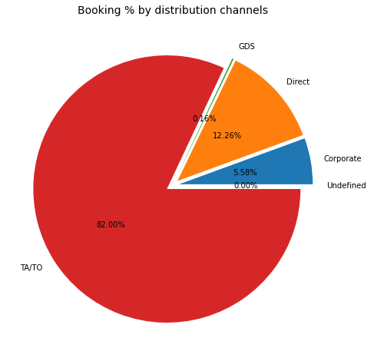

**Conclusion :**

* Around 60% bookings are for City hotel and 40% bookings are for Resort hotel, therefore City Hotel is busier than Resort hotel. Also the overall of City hotel is slightly higher than Resort hotel.
* Mostly guests stay for less than 5 days in hotel and for longer stays Resort hotel is preferred.
* Both hotels have significantly higher booking cancellation rates and very few guests less than 3 % return for another booking in City hotel. 5% guests return for stay in Resort hotel.
* Most of the guests came from European countries, with most no. of guest coming from Portugal.
* Guests use different channels for making bookings out of which most preferred way is TA/TO.
* For hotels higher ADR deals come via GDS channel, so hotels should increase their popularity on this channel.
* Almost 30% of bookings via TA/TO are cancelled.
* Not getting same room as reserved, longer lead time and waiting time do not affect cancellation of bookings. Although different room allotment do lowers the ADR.
* July-August are the most busier and profitable months for both of hotels.
* August are the most busier and profitable months for both of hotels.
* Within a month, ADR gradually increases as month ends, with small sudden rise on weekends.
* Couples are the most common guests for hotels, hence hotels can plan services according to couples need to increase revenue.
* More number of people in guests results in more number of special requests..
* Bookings made via complementary market segment and adults have on average high no. of special request..
* For customers, generally the longer stays (more than 15 days) can result in better deals in terms of low ADR.